**Exercise – 5**

**Pre requisite:**

* **To create a branch “Git-T03_HOL_002”.**

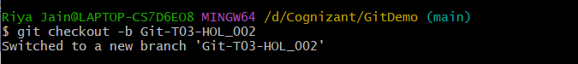

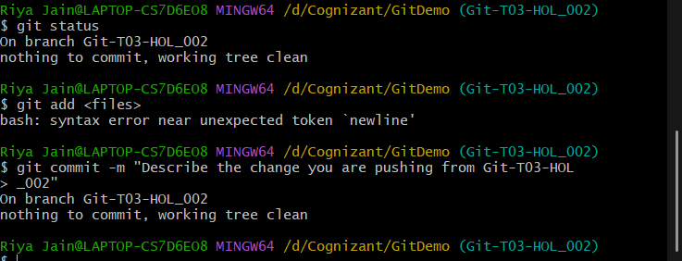

**Step 1: Verify if main/master is in clean state.**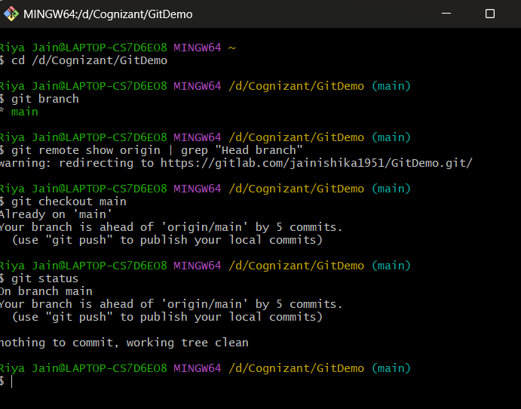

**Step 2: List out all the available branches.**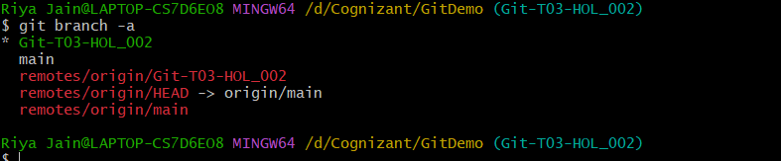

**Step 3: Pull the remote git repository to the master/main.**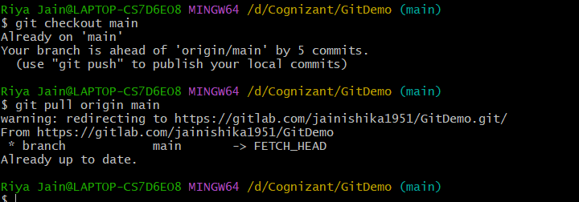

**Step 4: Push the changes, which are pending from “Git-T03-HOL_002” to the remote repository.**

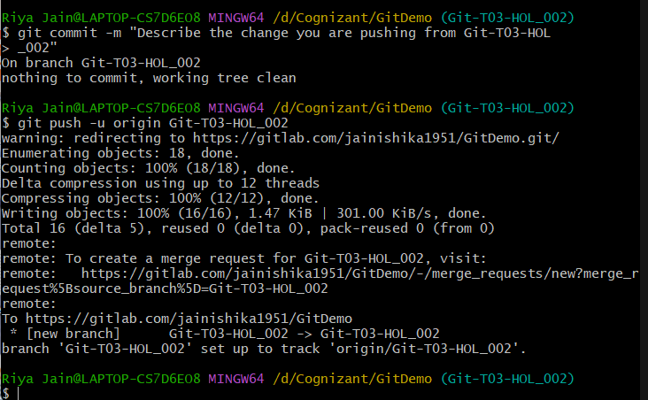

**Step 5: OUTPUT(Changes reflected in the remote repository).**

